Name: _____________________________ Date: _____________Total Marks: ___________________

Creating a Composite Control for Validating Data

Instructions

- Create a new windows control library named ctlValidatingDataLib.
- Select UserControl.cs and rename it to ctlValidatingData.cs. Click the Yes button when you are asked if you want to rename all references to the code element “UserControl1”.
- Add the required controls to the UserControl. Arrange the controls and change their Text properties as shown in Figure 1.
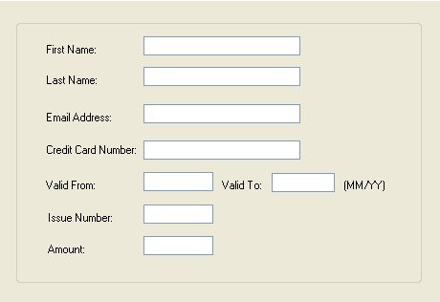
Figure 1 – Validating Data
- The validation should address the following errors:
- Error: Please enter a valid email address
- Error: Please enter a valid credit card number
- Error: Please enter an expiry date
- Error: Please enter an amount
- On the File menu, click Save All to save the project.

